**Exploring the Art World: Data Analysis and Insights into Paintings, Artists, and Museums**

**Project Objective**

The objective of this project is to analyse a comprehensive dataset related to paintings, artists, museums, and related attributes to gain valuable insights into the art world. By leveraging data analytics techniques, the project aims to address key questions and uncover actionable insights that can inform decision-making processes within the art industry. Through a structured analysis approach, the project seeks to provide stakeholders with valuable information regarding museum operations, artist popularity, painting styles, pricing dynamics, and international presence.

**Data Cleaning Process**

1. **Handling Missing Values**: Identify and address missing values in critical fields such as museum ID, painting style using appropriate imputation techniques or removing incomplete records.

2. **Duplicate Record Removal**: Eliminate duplicate records from relevant tables, including work, product size, subject to ensure data integrity and accuracy.

3. **Data Validation**: Validate and rectify any invalid entries or inconsistencies in fields such as museum hours, city names, and date/time formats to enhance data quality and reliability.

4. **Standardization**: Standardize data formats and resolve inconsistencies across fields to facilitate seamless analysis and interpretation of results.

**Step-by-Step Analysis:**

1. **Exploratory Data Analysis (EDA):**

- I conducted descriptive analysis to understand the distribution and characteristics of key variables such as painting style, artist, museum, and pricing attributes.

2. **Museum Analysis:**

- I evaluated the number of paintings displayed in each museum to identify top-performing institutions.

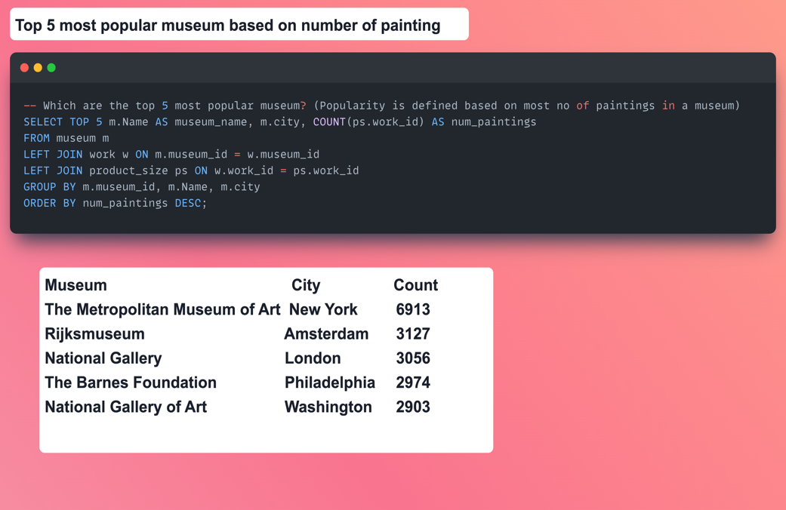

- I analysed museum opening hours, geographical distribution, and visitor traffic patterns to assess operational efficiency and visitor accessibility.

3. **Artist Analysis**:

- I ranked artists based on the number of paintings attributed to them to identify influential artists.

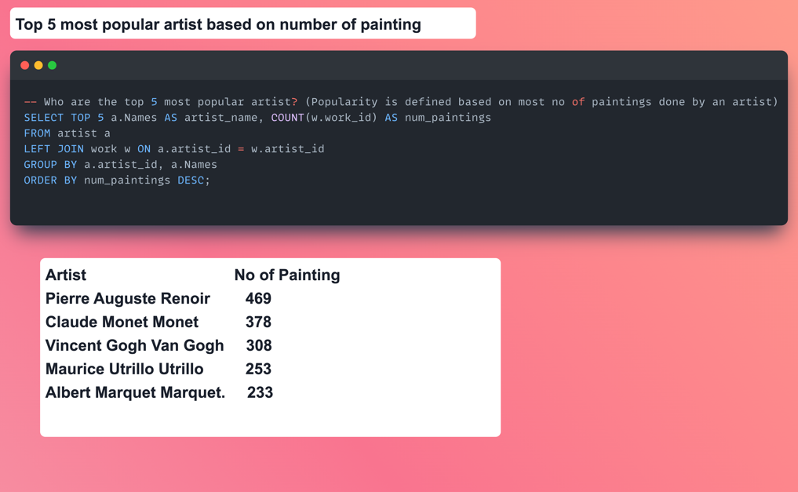

- I explored artist nationality, painting subjects, and stylistic preferences to understand artistic trends and influences.

4. **Painting Analysis:**

- I investigated pricing dynamics by comparing asking prices to regular prices and identifying paintings with significant price differentials.

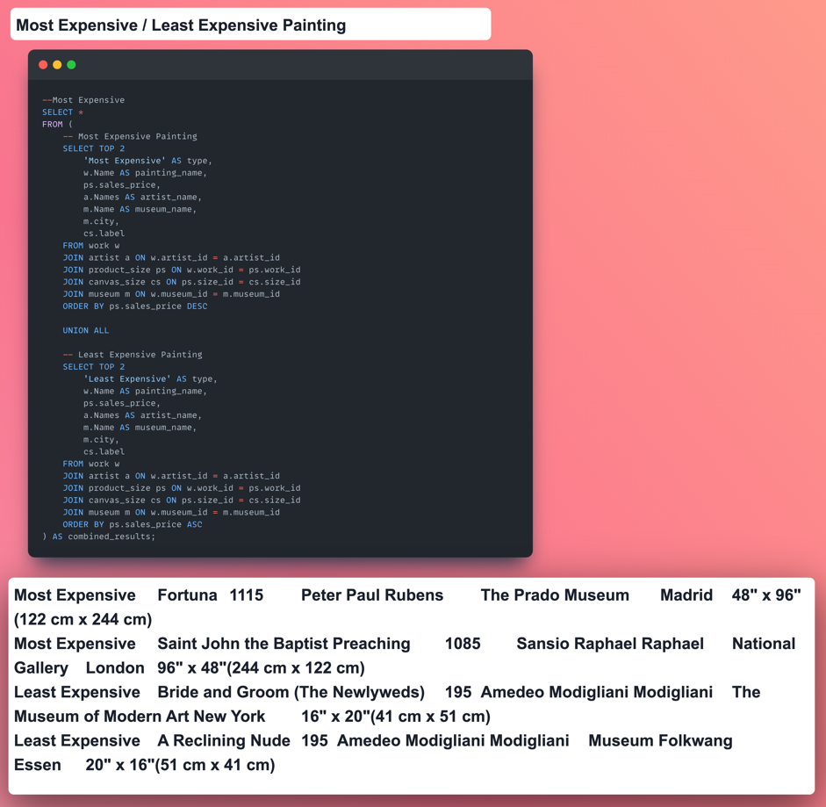

- I analysed painting styles, sizes, and subjects to identify popular and emerging trends in the art market.

**Important Insights:**

1. Identification of top-performing museums based on painting count, geographical location, and visitor engagement metrics.

2. Recognition of influential artists and their contributions to the art world based on painting count and stylistic preferences.

3. Understanding of pricing dynamics and market trends, including variations in asking prices and regular prices across paintings and museums.

4. Discovery of popular painting styles, subjects, and sizes among collectors and museums, with insights into evolving trends and preferences.

**Conclusions**

1. The analysis provides valuable insights into various aspects of the art industry, including museum operations, artist popularity, pricing dynamics, and painting preferences.

2. Understanding these insights can help stakeholders make informed decisions regarding art collection, exhibition curation, pricing strategies, and investment opportunities.

3. The findings highlight the importance of data-driven approaches in the art industry and underscore the potential benefits of leveraging data analytics for informed decision-making.

**Recommendations**

1. Museums can use insights from the analysis to optimize their exhibition strategies, enhance visitor experiences, and expand their art collections strategically.

2. Artists can leverage insights into stylistic preferences, pricing dynamics, and market trends to tailor their artworks to meet collector demands and enhance their visibility in the art market.

3. Art collectors and investors can benefit from the analysis by making informed decisions regarding art acquisitions, pricing negotiations, and investment strategies.

4. Continued research and analysis are recommended to monitor evolving trends in the art industry and adapt strategies accordingly to capitalize on emerging opportunities and mitigate risks.

By executing this project, we aim to provide stakeholders in the art industry with valuable insights and actionable recommendations that can drive strategic decision-making and foster growth and innovation within the sector.